### 

**Explore AS,**

PROJECT TITLE: AI-POWERED NUTRITION ANALYZER FOR FITNESS ENTHUSIASTS

#### 1. CUSTOMER SEGMENT(S)

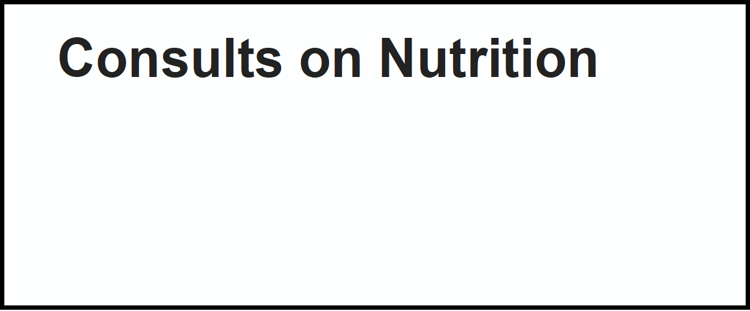Who is your customer?

**Deﬁne CS, ﬁt into**

## CS

#### 6. CUSTOMER

What constraints prevent your customers from taking action or limit their choices

of solutions? i.e. spending power, budget, no cash, network connection, available devices.

# Network connection, Cost, Time, Poor Knowledge, Lack of Resources.

**Focus on J&P, tap into BE, understand**

## CC

#### 5. AVAILABLE SOLUTIONS

Which solutions are available to the customers when they face the problem

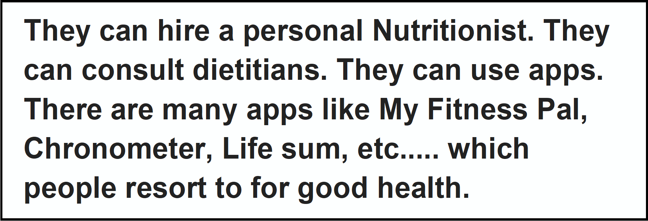or need to get the job done? What have they tried in the past? What pros & cons dothese solutions have? i.e. pen and paper is an alternative to digital notetaking

Seat allotment, Eligibility criteria, Previous year cut off, Exam scores like GRE, TOEFL, GATE etc.

Students

## AS

#### 2. JOBS-TO-BE-DONE / PROBLEMS

**Focus on J&P, tap into BE, understand**

Which jobs-to-be-done (or problems) do you address for your customers? There

## J&P

#### 9. PROBLEM ROOT CAUSE

What is the real reason that this problem exists? What is

## RC

#### 7. BEHAVIOUR

What does your customer do to address the problem and get the job done?

## BE

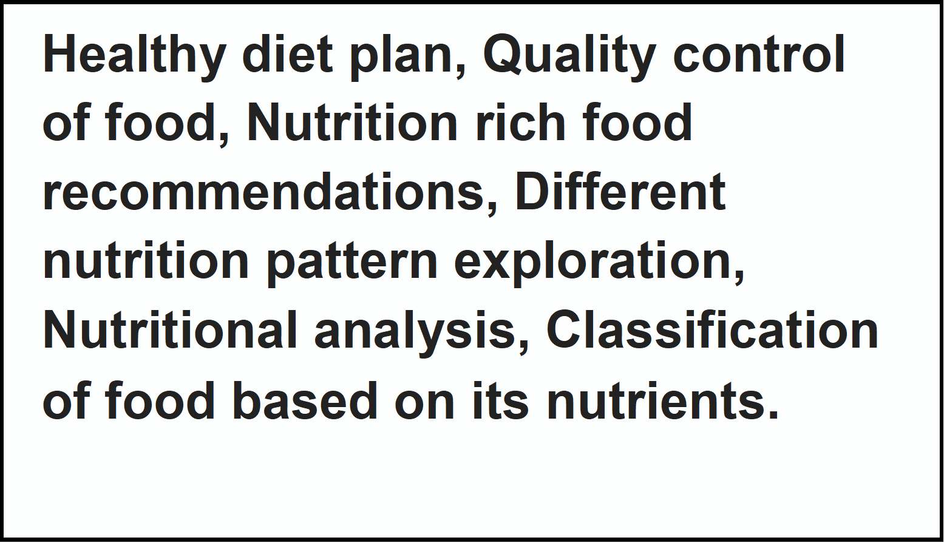could be more than one; explore different sides.

# High Fees structure, Placement Opportunities & Training, Courses Offered, Advanced Technology, Career development programmes.

the back story behind the need to do this job?

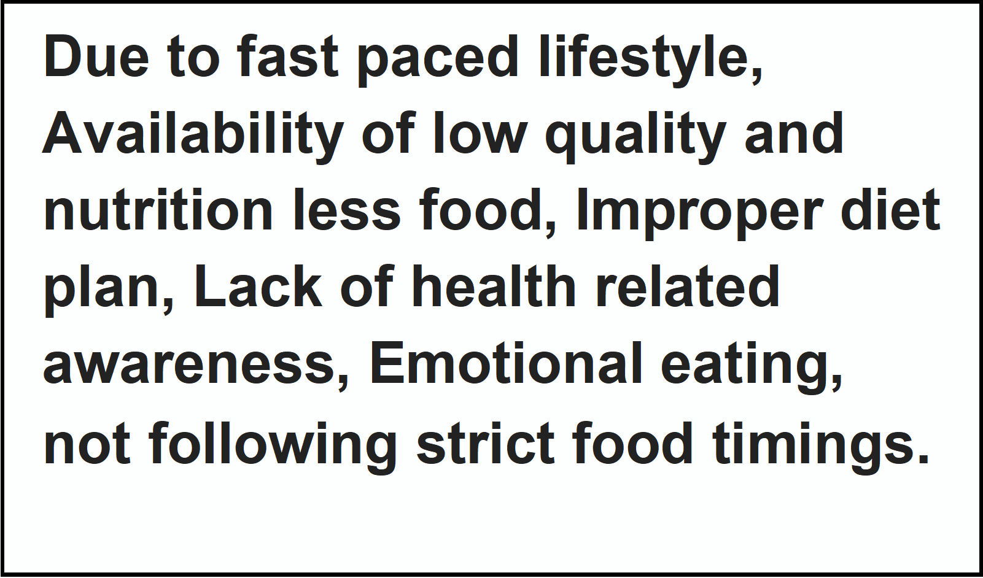i.e. customers have to do it because of the change in regulations.

# Lack of Placement Opportunities and Not meeting the Expected cut off.

Due to high Competition & less Opportunities results in the difficulty to choose a right college.

i.e. directly related: ﬁnd the right solar panel installer, calculate usage and beneﬁts; indirectly associated: customers spend free time on volunteering work (i.e. Greenpeace)

# Referring Articles & Checking websites, Visiting College premises, Academic Performance, Fees structure and Enquiring Alumni.

### 

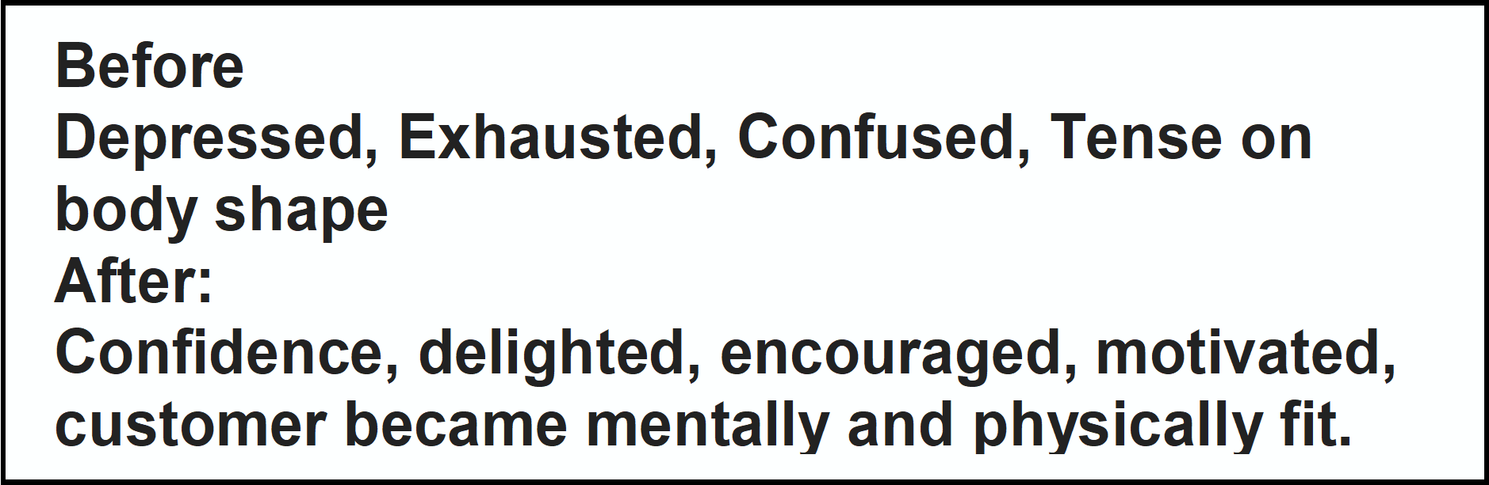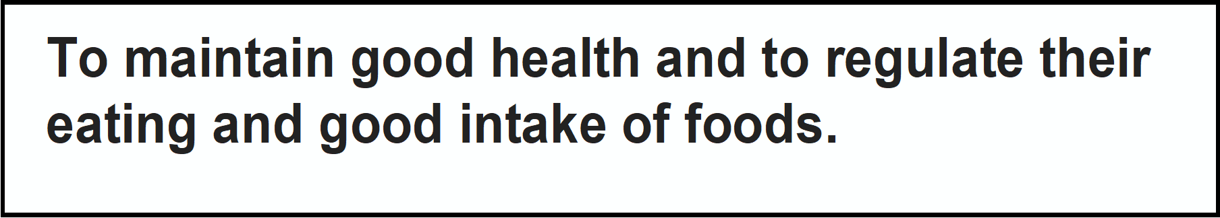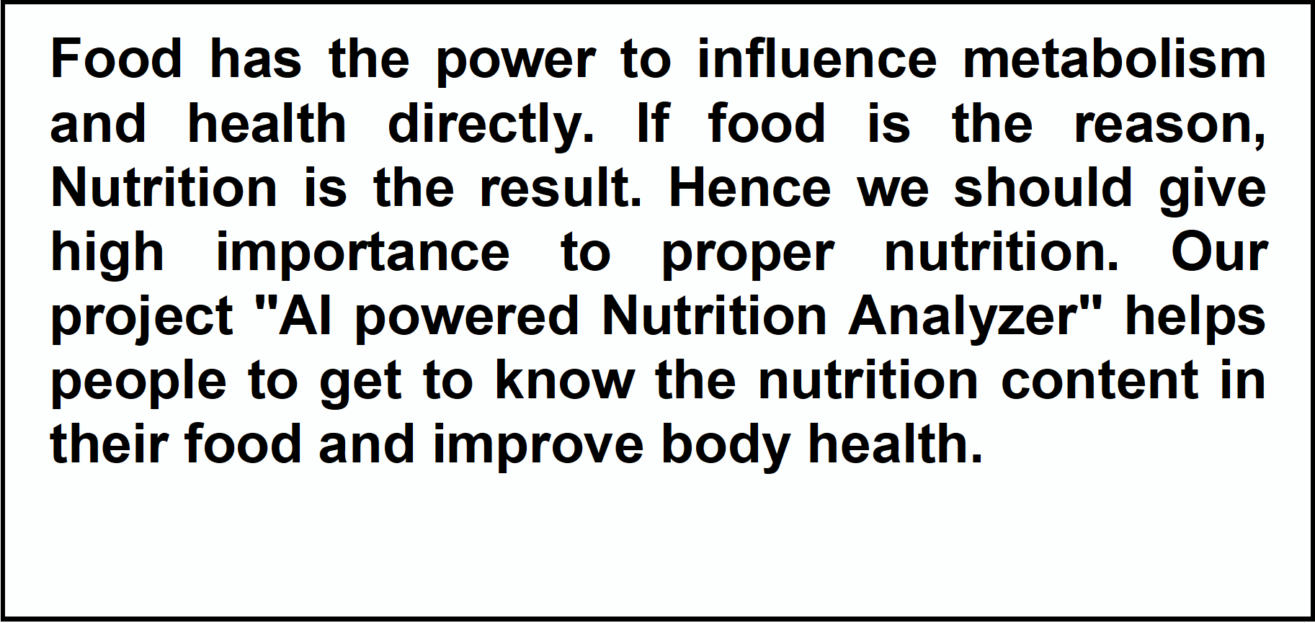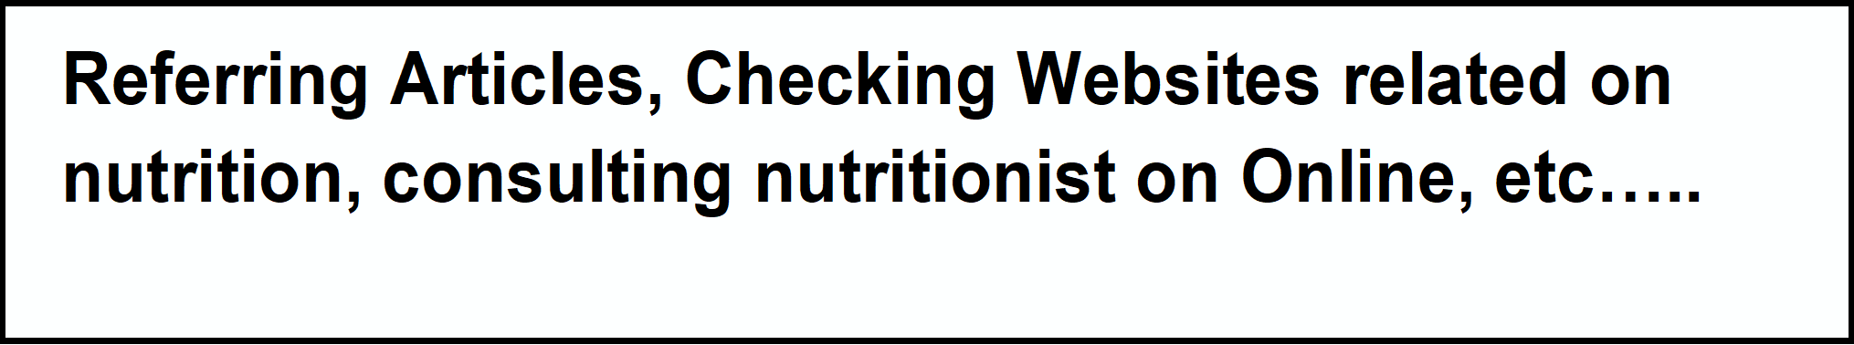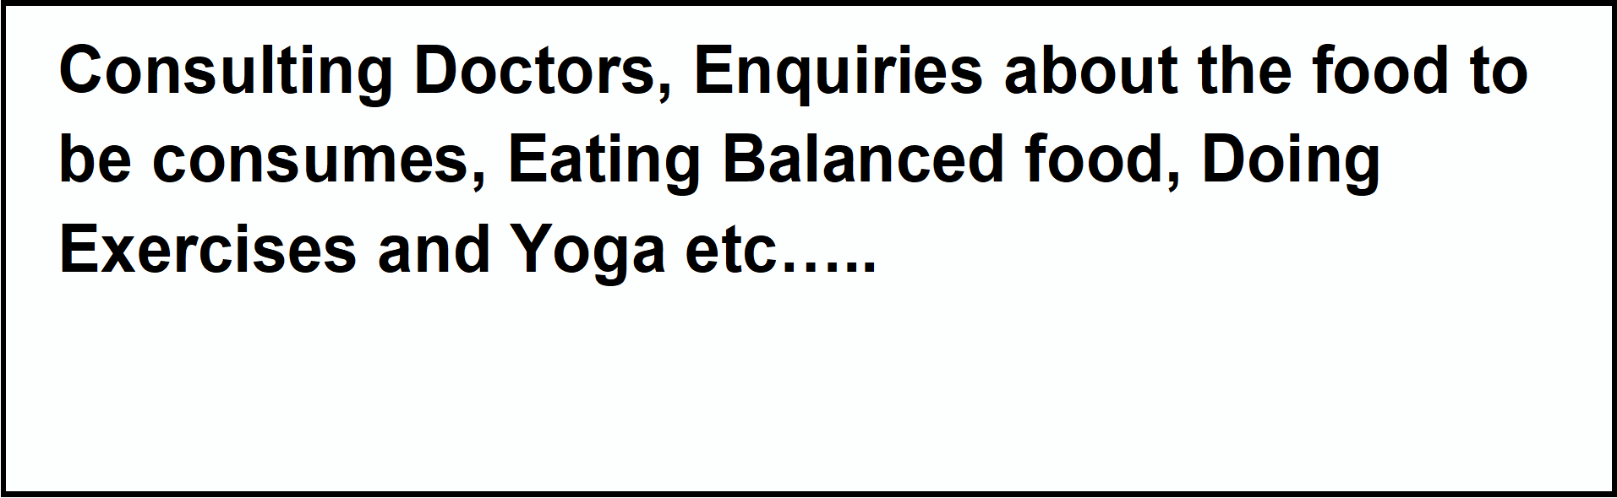i

|  |  |  |  |  |  |  |  |  |
| --- | --- | --- | --- | --- | --- | --- | --- | --- |
| **Identify strong TR & EM** |  | **3. TRIGGERS TR**  What triggers customers to act? i.e. seeing their neighbour installingsolar panels, reading about a more efﬁcient solution in the news.  To put a road map for future career & to get high paying job offers. |  | **10. YOUR SOLUTION SL**  If you are working on an existing business, write down your current solution ﬁrst,ﬁll in the canvas, and check how much it ﬁts reality.  If you are working on a new business proposition, then keep it blank until you ﬁll inthe canvas and come up with a solution that ﬁts within customer limitations, solves a problem and matches customer behaviour.  This idea helps students to get the list of colleges by comparing the student’s marks and college's cut off and predicting admission probability. Here the chance of occurrence of error is less when compared to existing system. It is fast, efficient and reliable. It helps you to understand as to how your profile can be further improved to secure an admit in your target college. |  | 1. **CHANNELS of BEHAVIOUR CH**     1. **ONLINE**   What kind of actions do customers take online? Extract online channels from #7  Referring Articles & Websites, Advertisements, College Reputation, Courses Available, List of Top Colleges, Eligibility Criteria, Previous Placements.   * 1. **OFFLINE**   What kind of actions do customers take ofﬂine? Extract ofﬂine channels from #7and use them for customer development.  Visiting College campuses, Food & Accommodation, Transport & Lab facilities, Enquiring College students, Speaking to Academic representatives. |  | **Extract online & ofﬂine CH of BE** |
|  | **4. EMOTIONS: BEFORE / AFTER EM**  How do customers feel when they face a problem or a job and afterwards?  .e. lost, insecure > conﬁdent, in control - use it in your communication strategy & design.  Confused, Anxious about peer group, Exciting & Enthusiastic & Friendly Faculties. |